TeleMega Checklist SRT-3

# Positioning the Telemega

* Depending on the orientation of the TeleMega board at power activation the board will enter “idle” or “flight” mode.
* If the rocket is on the launch rail, powering on the TeleMega will place it in “flight” mode
* If the rocket is horizontal, powering on the TeleMega will place it in “idle” mode
* If you wish to test pyro ignitors the TeleMega circuit board must be horizontal and have a USB connection to a computer
* In order to position the TeleMega for flight the rocket must be vertical at which point the TeleMega must be powered on or given a reboot order if already on

# Checking for Secure Connections

**Tele Mega Screw Terminals Diagram**

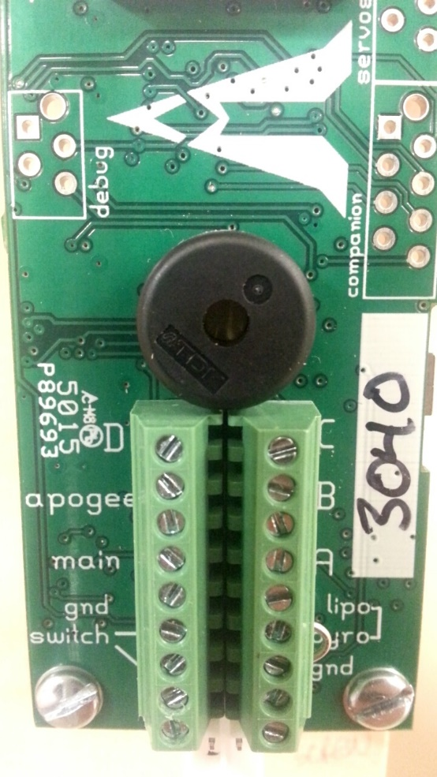

1 2 3 4 5 6 7 8 9

Top

Bottom

|  |  |  |
| --- | --- | --- |
| **Terminal #** | **Terminal Name** | **Description** |
| Top 1 | Switch Input | Switch connection to positive battery terminal |
| Top 2 | Switch Output | Switch connection to flight computer |
| Top 3 | *Ground* | Ground connection for use with external active switch |
| Top 4 | Main - | Main pyro channel for connection to pyro circuit |
| Top 5 | Main | Main pyro channel common connection to battery |
| Bottom 1 | *Ground* | Ground connection for negative pyro battery terminal |
| Bottom 2 | Pyro | Positive pyro battery terminal |

**Tele Mega Wiring Diagram**

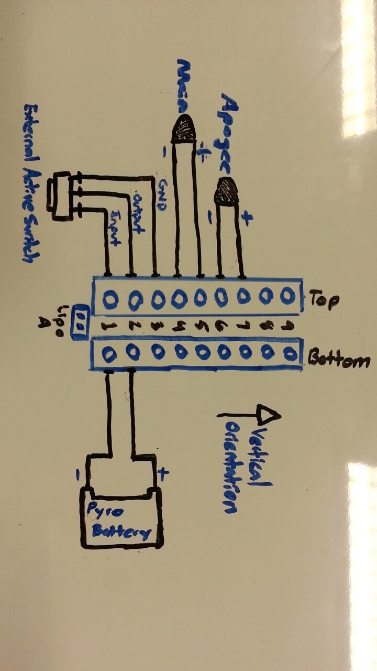

# Starting up the Telemega

* To start up the TeleMega the external switch connected to the TeleMega must be activated
* The switch is positioned through the body tube hole leading into the electronics bay
* To activate the switch use the appropriate key and insert the key through the body tube hole and turn **clockwise**. **Do not overtighten.**
* Refer to previous section on positioning and “idle” & “flight” mode
* Depending on the position of the circuit board the TeleMega is now powered on and awaiting launch